Backoffice
1. Environment Variable
Setup EASYPAY_MANUAL_DEPOSIT_BACKEND_URL, EASYPAY_MANUAL_DEPOSIT_ENABLED
EASYPAY_MANUAL_DEPOSIT_BACKEND_URL = https://{domain}/app/api/payment/easypay/manualdeposit/callback/
EASYPAY_MANUAL_DEPOSIT_ENABLED = 1
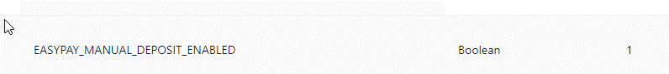

2. Skin Config
PG Provider select Easypay Manual, Upload Easypay Manual Deposit Images
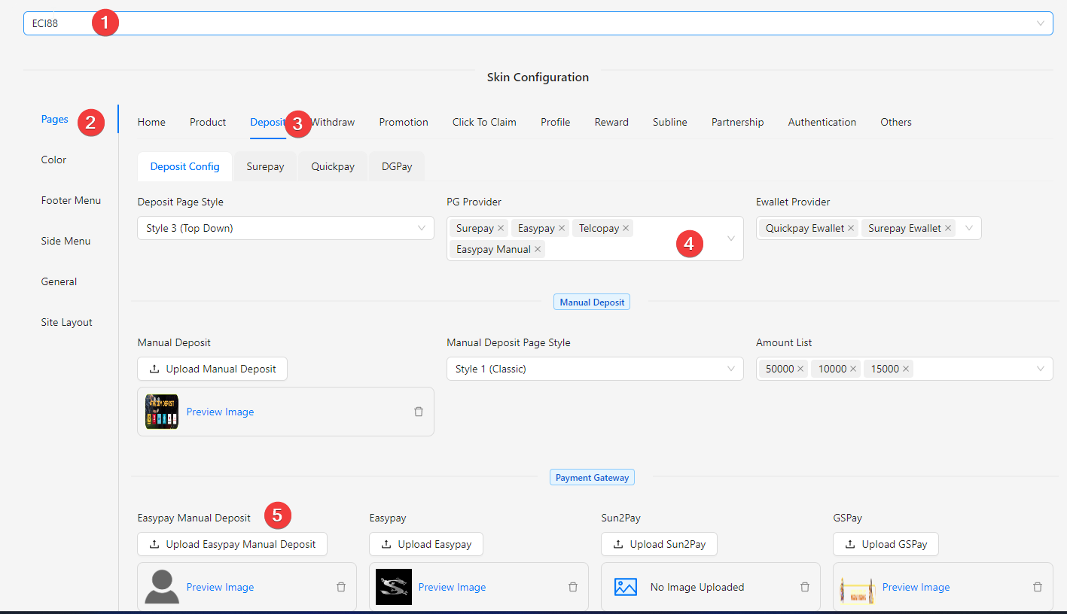

Easypay
https://easypay88.com/ login as superadmin
- Create partner (Only if the partner is not created, shared with pg partner)
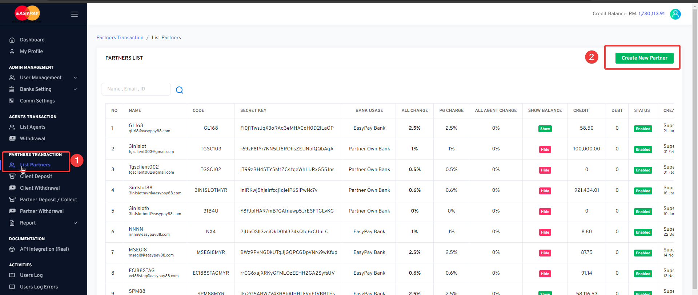
- Create Bank Account
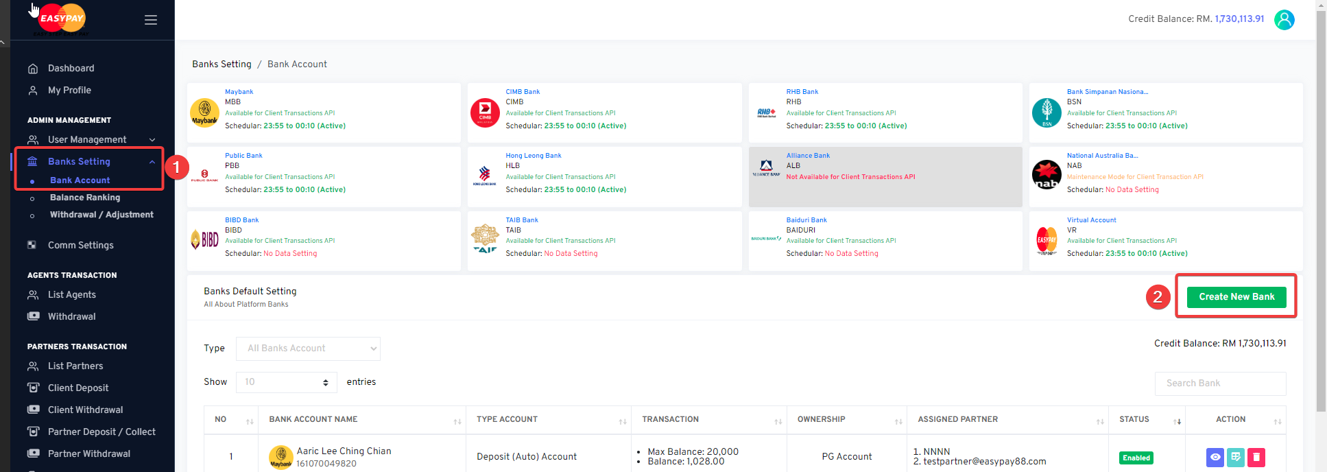
Type: Manual Deposit Account
OwnerShip: Partners
Partners: {Choose the partner account}
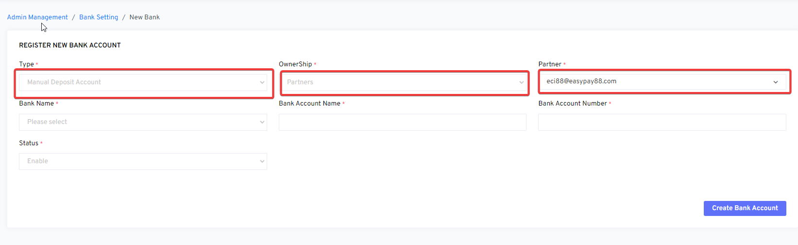

- After created bank in superadmin account, partner can view the bank in profile
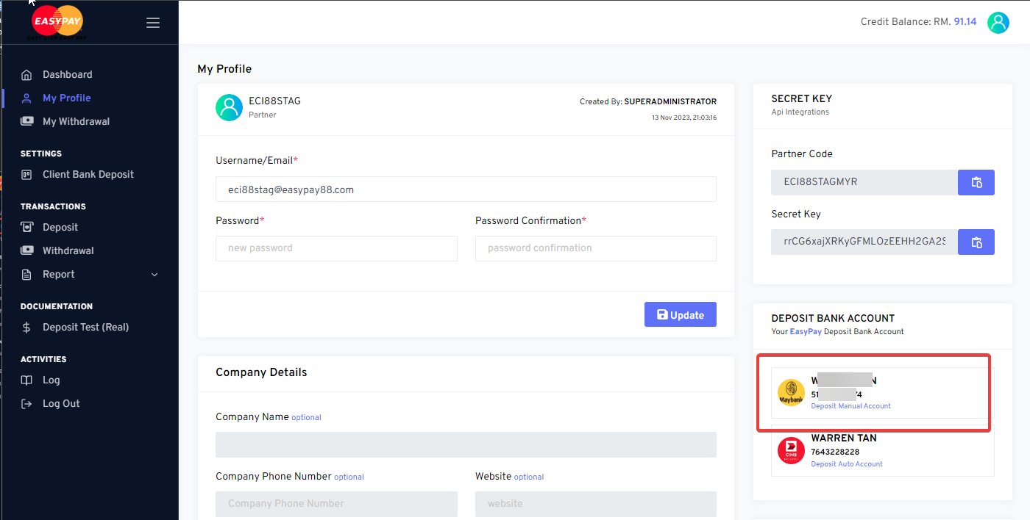
- Create an admin role account
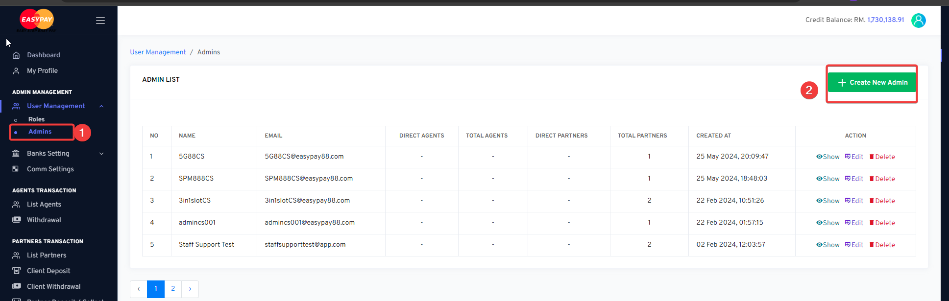
Name And Email better end with CS for easy manage
Role: Staff
Partner has to assign
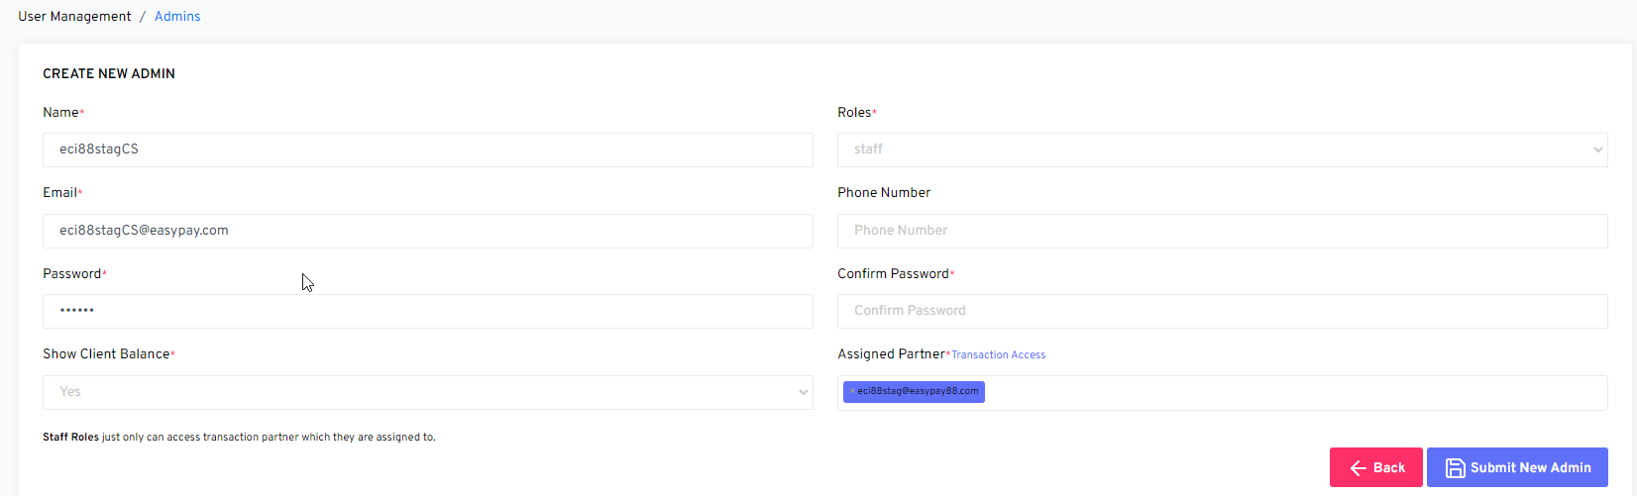

- Then in FE we can see the account
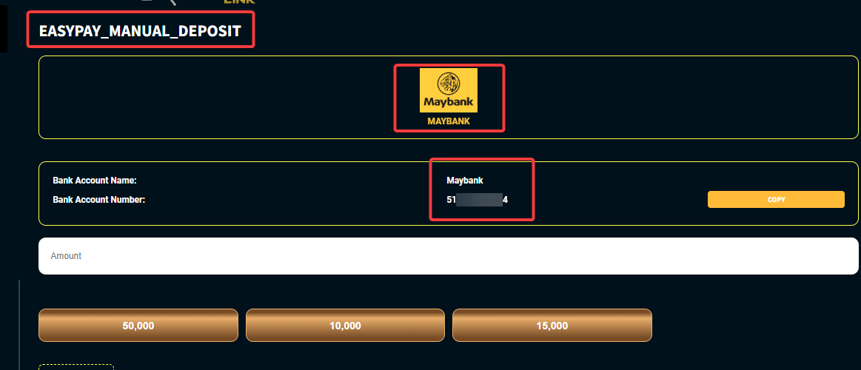
- Login admin role account, go to client deposit
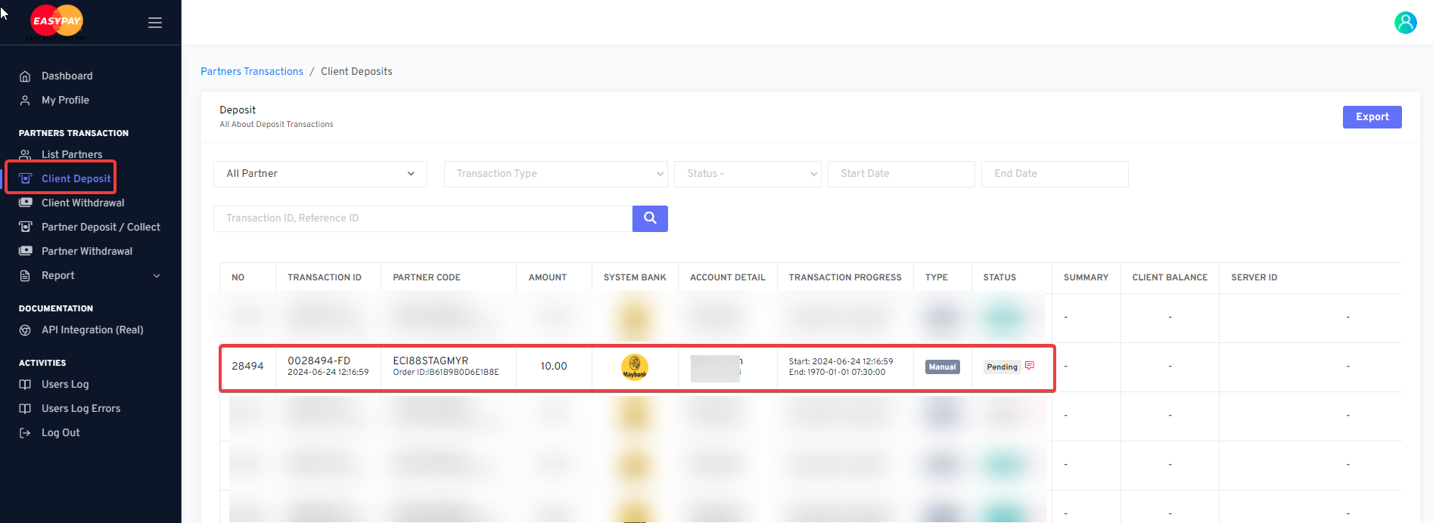
Click the eye (Action)

And then can approve / reject the transaction
